**Assertions Test**

To validate logic in Java programs using various **JUnit assertion methods**.

**Tools Used:**

* **IDE**: IntelliJ IDEA
* **Testing Framework**: JUnit 4.13.2
* **Language**: Java
* **Build Tool**: Maven

**Steps Followed:**

**1. Created a JUnit Test Class**

* File: AssertionTest.java

**2. Imported Required Classes**

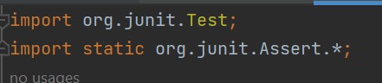

**3. Implemented Assertion Tests**

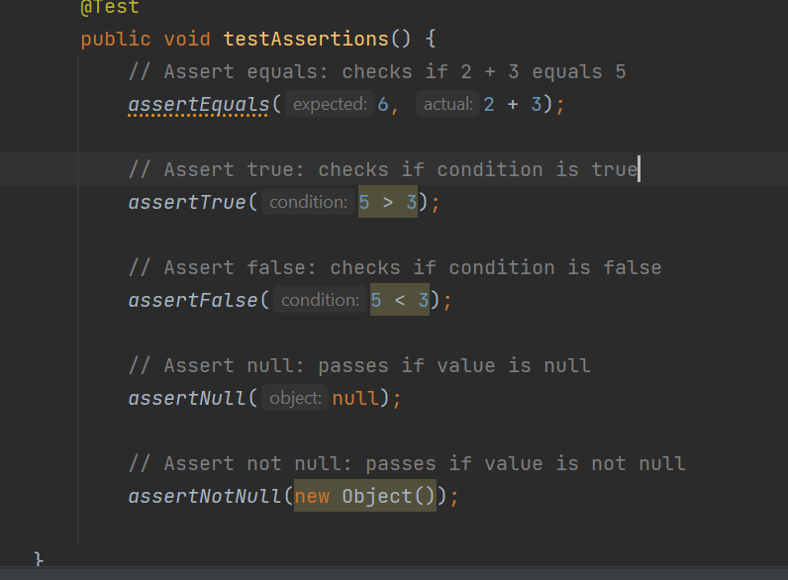

**Explanation of Assertions Used:**

| **Assertion** | **Purpose** | **Example** |
| --- | --- | --- |
| assertEquals(a, b) | Check if a == b | assertEquals(5, 2 + 3) |
| assertTrue(cond) | Check if condition is true | assertTrue(5 > 3) |
| assertFalse(cond) | Check if condition is false | assertFalse(5 < 3) |
| assertNull(obj) | Check if object is null | assertNull(null) |
| assertNotNull(obj) | Check if object is **not** null | assertNotNull(new Object()) |

**Result:**

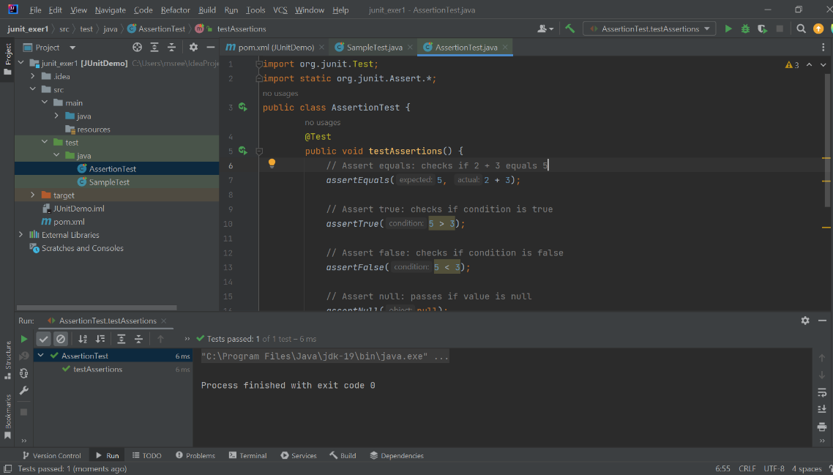when all tests passed

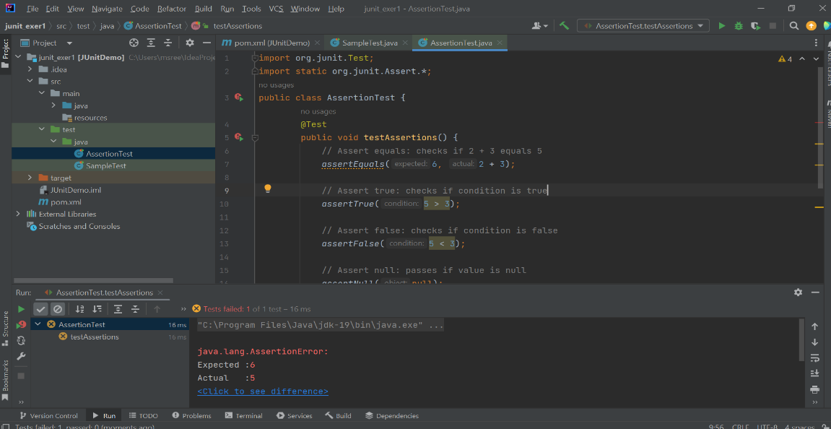when assertequals(6,2+3) fails